Natural Disasters Project

Research a Natural Disaster that has occurred in our World and present your findings as either a booklet or poster. You must investigate the following
aspects of the disaster and use them as sub-headings in your project:
• Where, When, What Type of disaster occurred.
• Explain how this type of disaster happens.
• How the disaster affected the people and land in that area.
• What the aftermath has been following the disaster.
• Any technological advancement that has been created to monitor or
predict future disasters.
• What preparations are made or taken in an emergency situation for
your disaster.

Elements to consider:
• Your information needs to be written in your own words.
• Subheadings to divide up your research.
• Neat presentation skills that show a mixture of information and pictures
or diagrams.
• References listed. eg, books, websites, videos

You will present your project and what you have found out about this disaster to your class. Remember, preparation is important when giving a spoken presentation to give you the confidence to speak well in front of an audience.

Project Due Date:

Possible Disaster Topics:

Black Saturday Bushfires 2009, Ash Wednesday Bushfires 1983,

Hurricane Katrina 2005, Tokyo Earthquake 1923, 1995,

Boxing Day Indonesian Tsunami 2004, Christchurch Earthquake 2011,

Newcastle Earthquake 1989, Cyclone Tracy 1974,

Volcano Mount St Helens 1980, Volcano Mt Etna 1669, 2000,

Volcano Mt Vesuvius 79AD, Japanese Tsunami 2011,

Typhoon Cobra 1944, California Earthquake 1989, 1994,

Typhoon Haiyan 2013.

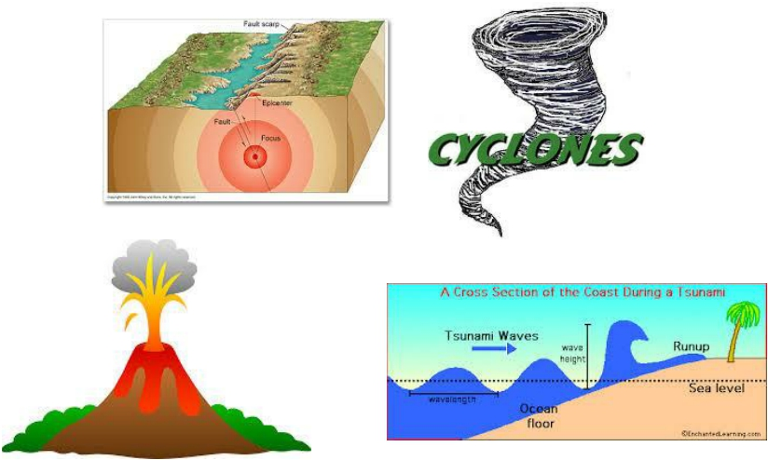

Use the checklist below to help with your time management to organise your
project. You have four weeks to complete your project.
Week 1 | Week of Sept 25th | Research and choose your natural disaster and print  off info.
Week 1 | Week of Sept 25th | Write info into your own words and use  subheadings.
Week 1 | Week of 25 | Continue writing up findings and source pictures.
Week 2 | Week of Oct 2 | Put project together and prepare to hand in
Week 2 | Oct 2 | Project Due.
Tick off when you complete each sub heading section: ✓
Where, When, What Type of disaster occurred.
Explain how this type of disaster happens.
How the disaster affected the people and land in that
area.
What the aftermath has been following the disaster.
Any technological advancement that has been created
to monitor or predict future disasters.
What preparations are made or taken in an emergency situation for your disaster.

