**AWM 11 – UNIT 1 – WORKING WITH GRAPHS**

|  |  |  |  |
| --- | --- | --- | --- |
| **Assignment** | **Title** | **Notes to Self** | **Complete** |
| **1** | ***Introduction to Statistics*** |  |  |
| **2** | ***Bar Graphs*** |  |  |
| **3** | ***Double Bar Graphs*** |  |  |
| **4** | ***Broken Line Graphs*** |  |  |
|  | ***Quiz 1*** |  |  |
| **5** | ***Histograms*** |  |  |
| **6** | ***Histograms*** |  |  |
| **7** | ***Circle Graphs*** |  |  |
| **8** | ***Circle Graphs*** |  |  |
| **9** | ***Circle Graphs*** |  |  |
| **10** | ***Misleading Graphs*** |  |  |
|  | ***Quiz 2*** |  |  |
| **Practice Test** | **Practice Test**  How are you doing? | Ask teacher. |  |
| **Self-Assessment** | **Self-Assessment** | On the next page, complete the self-assessment. |  |
| **Unit Test** | **Unit Test**  Show me your stuff! |  |  |

**Self Assessment**

On the following chart, indicate how confident you feel about each statement.

**1 – I need more help 2 – I need more practice 3 – I could teach it !**

Discuss this with your teacher ***before*** you write the test!

|  |  |
| --- | --- |
| **Statement** | ☹ 😐 ☺ |
| After completing this chapter: |
| * I can determine the types of graphs that can be used to represent given data |  |
| * I can explain the advantages and disadvantages of different types of graphs |  |
| * I can create a bar graph, a broken line graph, a histogram, and a circle graph |  |
| * I can interpret bar graphs, broken line graphs, histograms, and circle graphs in order to answer questions about the data |  |
| * I can discuss the trends a graph represents for a given set of data |  |
| * I can explain how different graphs of the same data can be used to be misleading |  |

**Vocabulary: Unit 1**

angle

bar graph

broken line graph

circle graph

histogram

statistics

trend

**INTRODUCTION TO STATISTICS**

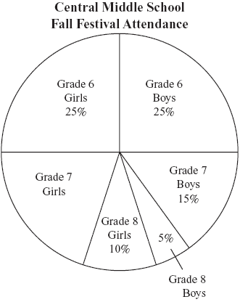**Statistics** is the branch of mathematics that works with data. It involves collecting data, organizing the data in some way, and interpreting it. This section will focus on organizing data.

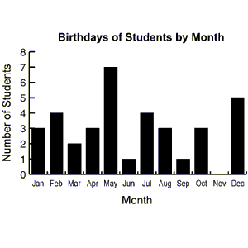There are many different ways to organize or present data: tables, charts, graphs, etc. Data is often presented visually in the form of **graphs**. In this unit you will learn about different types of graphs and their uses. These include bar graphs, broken line graphs, histograms, and circle (pie) graphs.

Finally, you will also discuss how graphs can be misleading..

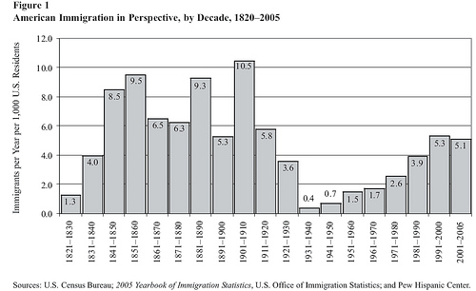**Graphs**

Although there are many types of graphs, there are many similarities between many graphs. All graphs must have labels to allow the viewer to know what they are reading. Without that, a graph is just another pretty picture rather than being a visual representation of data. And all graphs must have a title.

On most graphs, there are two axes (plural of axis), one axis goes horizontally (↔) and the other goes vertically (↕). Each axis needs a label describing what it is showing (months, cost, number of something, etc.) and a scale if it is a number quantity. When assigning the scale, it is important to remember that each line of the grid paper **MUST** represent the same amount on that graph. And remember to label lines, not spaces.

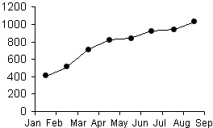

All bar graphs, broken line graphs and histograms **MUST** be constructed on grid paper. Circle graphs will be done on a blank circle graph using a protractor. **no exceptions**. As well, all graphs need a title summarizing what they are showing.

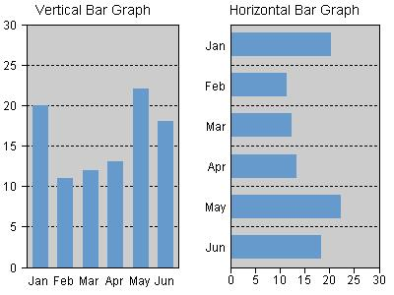**Bar Graphs**

A **bar graph** is a visual representation used to show comparison. On a bar graph, the bars can be horizontal or vertical as shown on the right. Most bar graphs are drawn with vertical bars. The values plotted are discrete, meaning they have a distinct or exact value. There is always the same amount of space between the bars and the bars are always the same thickness.

|  |  |
| --- | --- |
| Colour | Number |
| Blue | 50 |
| Green | 45 |
| Red | 54 |
| Orange | 49 |
| Yellow | 52 |

When drawing a bar graph with vertical bars, the horizontal axis does not have a scale, it just names each bar. The vertical axis will need a scale. For this Math course, each vertical scale must start at **zero**, and end just above the highest data value unless otherwise specified (negative temperatures). For example, if your data consisted of the information below, you would start your vertical axis at zero and the top value might be 55 if increments go up by 5, or 56 if increments go up by 2.

***For this course, the bars in the graph should not be coloured with individual colours, but all one colour. A highlighter is fine, or they can be simply shaded with a pencil.***

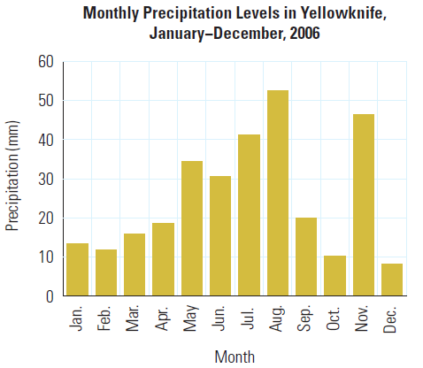Example 1: Use the bar graph below to answer the following questions.

a) What is the title of this graph?

b) What is the precipitation that fell in October?

c) Which months have precipitation greater than or

equal to 30 mm?

d) Which season would you say is the rainy season in Yellowknife?

Solution: Use the information on the graph to answer the questions.

a) The title is “Monthly Precipitation Levels in Yellowknife, January – December, 2006”

b) About 10 mm of precipitation fell in October

c) May, June, July, August, November

d) Summer is the rainy season.

Example 2: Create a vertical bar graph using the data in the table below.

|  |  |  |  |  |  |  |
| --- | --- | --- | --- | --- | --- | --- |
| **Favourite Colour of Grade 3 Students** | | | | | | |
| Colour | Blue | Green | Yellow | Red | Orange | Purple |
| Number of Students | 16 | 5 | 3 | 18 | 11 | 8 |

Solution: Draw and label the axes, set a scale, and plot the data accordingly.

The horizontal axis is labelled “Colour” while the vertical axis is labelled “Number of Students.” The scale must go up from 0 and a good top value would be 20 with the increment of 2 for each line. The data is plotted as shown below.

Note that this graph was produced using a software program so it might look slightly different when done with pencil and paper.

Example 3: The following data is shown in both a vertical and horizontal bar graph. Which graph is a better representation of the data and why?

|  |  |  |  |  |  |  |
| --- | --- | --- | --- | --- | --- | --- |
| ***Population of Anywhere City, BC, 1980 – 2005*** | | | | | | |
| Year | 1980 | 1985 | 1990 | 1995 | 2000 | 2005 |
| Population  (in thousands) | 33.5 | 34.3 | 33.4 | 32.8 | 32.0 | 32.0 |

Solution: The graphs are plotted below.

Population of Anywhere City BC, 1980 – 2005

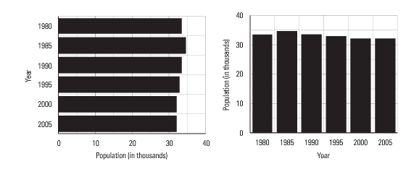

The vertical bar graph on the right seems to have the better representation as it is easier to see that the population is dropping from 1995 to 2005. Using the graph to assess this statistic is called determining the **trend** of the data. In this case, the trend is a slight decrease in population over the time covered by the graph.

**ASSIGNMENT 2 – BAR GRAPHS**

1) Use this bar graph to answer the following questions.

How many DVDs were sold on:

1. Monday? _________________________________________
2. Tuesday? ________________________________________
3. Wednesday? _____________________________________
4. Thursday? _______________________________________
5. Friday? __________________________________________

On which days were:

1. More than 130 DVDs sold? ______________________________________
2. 120 or more DVDs sold? ________________________________________
3. Fewer than 130 DVDs sold? _____________________________________
4. 150 or fewer DVDs sold? ________________________________________

Were more DVDs sold on:

1. Monday or Wednesday? _______________________________________
2. Tuesday or Thursday? ________________________________________
3. Wednesday or Friday? ________________________________________

2) Create a bar graph for each of the following sets of data. Use the graph paper given below the chart of data. Plan your graph carefully so it fits on the graph paper and is not too small.

|  |  |
| --- | --- |
| Sport | Number |
| Tennis | 40 |
| Hockey | 36 |
| Soccer | 34 |
| Baseball | 44 |
| Football | 46 |

Favourite Sport

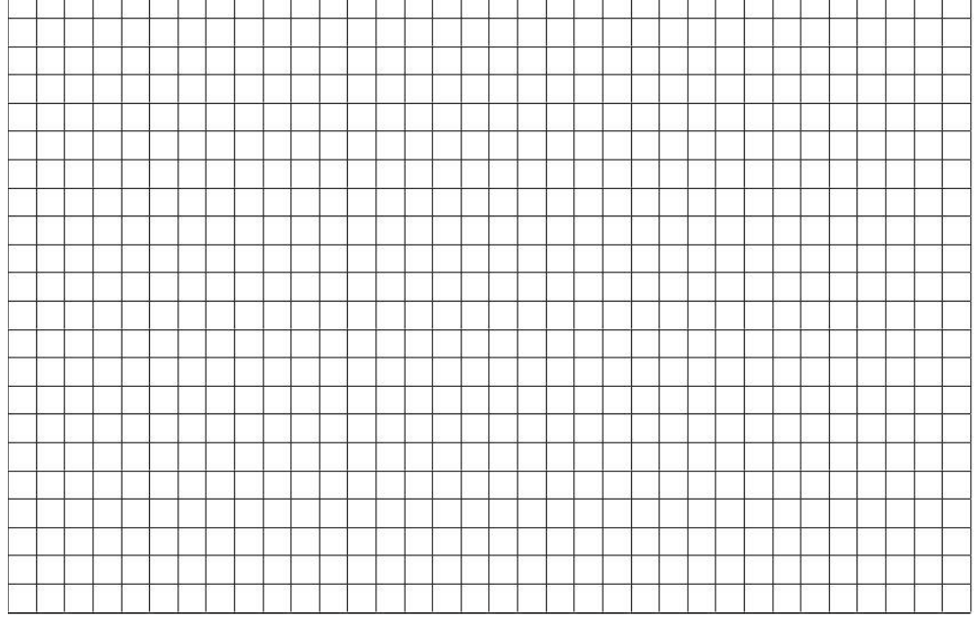

Math Test Scores

|  |  |
| --- | --- |
| Test Score | Number of students |
| 60 | 15 |
| 65 | 10 |
| 70 | 20 |
| 75 | 30 |
| 80 | 50 |
| 85 | 20 |
| 90 | 5 |
| 95 | 15 |



**Double Bar Graphs**

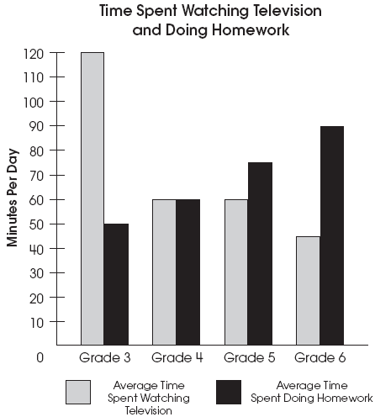Double bar graphs are used to compare two things and show the trends between both at the same time. Double bars graphs have everything the same as single bar graphs except they have two bars at each spot on the horizontal axis comparing some entity. Drawing double bars graphs follows the same set of rules as for single bar graphs. Examples of double bar graphs could be fuel consumption for different vehicles comparing highway and city driving or housing prices for new and resale homes, or the graph to the right.

This example of a double bar graph shows several key features; the pair of bars is the same width and touching each other. There is the regular space between sets of bars. There needs to be some form of a legend to indicate what different colours or patterns represents. And like ALL graphs, the axes are labelled, the vertical axis has a scale on it, and the graph has a title.

Example: Use the double bar graph to answer the following questions.

a) What are the two company names?

b) Which company is represented by the darker bar?

c) How many computers does each company sell?

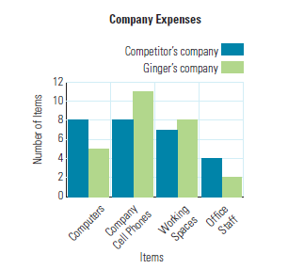d) How many working spaces does each company have?

e) Why would one company have more computers than working spaces?

Solution:

a) Competitor’s company and Ginger’s company

b) Competitor’s company

c) Competitor’s company - 8

Ginger’s company - 5

d) Competitor’s company - 7

Ginger’s company - 8

e) Some computers may be laptops and not used in a workspace.

**ASSIGNMENT 3 – DOUBLE BAR GRAPHS**

1) George did a survey at his school to find out what each student’s favourite sport was to watch on TV. The results are in the chart. Draw a double bar graph to represent this data on the graph paper below.

|  |  |  |  |  |  |
| --- | --- | --- | --- | --- | --- |
| ***Favourite Sport to Watch on TV*** | | | | | |
| Sport | Hockey | Soccer | Football | Baseball | Golf |
| Boys | 243 | 101 | 135 | 79 | 18 |
| Girls | 265 | 75 | 121 | 15 | 2 |

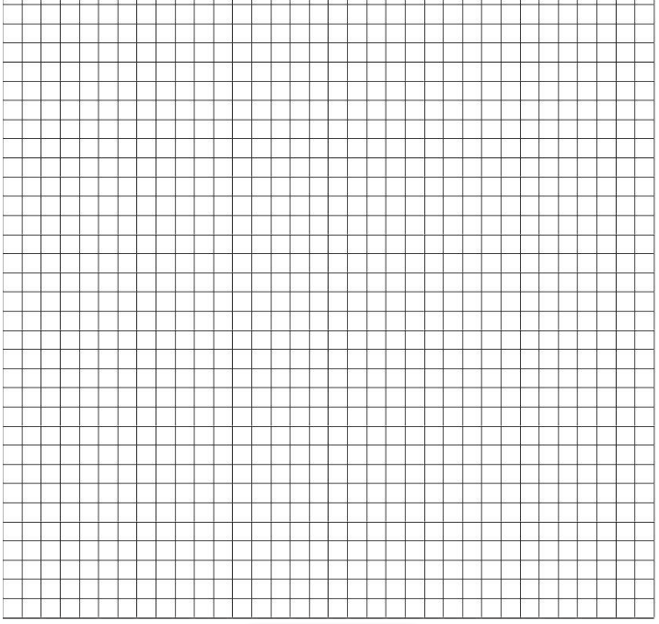

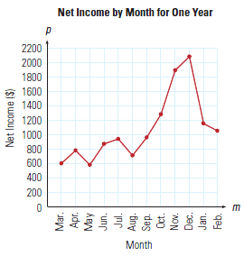**Broken Line Graphs**

A **broken-line** graph displays information by using a scale. It is similar to a bar graph, but it has points at the top of where the bars would be. These points are joined in individual line segments creating a “broken” line. It shows continuous change over a period of time. Just as with a bar graph, a broken line graph needs labels on the axes and a title.

Broken line graphs are used to show trends over time. By looking at just the line on a broken line graph rather than a set of bars on a bar graph, it is easier to discover the changes in the data over time. As with double bar graphs, broken line graphs can have more than one broken line on a graph.

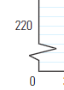

If you see a symbol like the one shown in the diagram to the right on an axis, it means that some amount of the axis has been omitted. If it is a scale, it is indicating that while the graph starts at zero, it really leaves out a large chunk of the values on the axis. DO NOT USE THIS TYPE OF SYMBOL OR METHOD. It produces inaccurate and misleading graphs which will be discussed later in this unit.

To construct a broken-line graph, complete the following steps.

1. Plan, draw and label the vertical scale to show the range of values. The label contains the words stating what the numbers are like metres, income, number if hours, etc. Remember to start at zero and to go just above the highest value. Each line MUST represent the same amount on your scale. If it is 5, your lines will go up like this: 0, 5, 10, 15, 20, 25, etc. It is not necessary to label every line with a number as it may get cluttered and hard to read.
2. Next plan, draw and label the horizontal scale. The spacing between each vertical line that you choose to label where you will plot a point MUST be consistent. For example, don’t leave two lines for the first 5 points and then only one line at the right side between points because you are running out of room! Plan your graph carefully!
3. Next, plot the points of data. To do this, find the values on each axis and where they meet, draw a small point.
4. When all the points are plotted, connect them **WITH A RULER**. Do not try to make the line one straight line. It is a series of line segments between each dot.
5. Finally, write a title for the graph that describes what the graph is illustrating.

**ASSIGNMENT 4 – BROKEN LINE GRAPHS**

1. Use the broken-line graph above to answer the following questions.

During which months does the graph show the first day to be:

1. 800 minutes or more minutes? ______________________________________
2. 750 or fewer minutes? ____________________________________________
3. Shorter than 600 minutes? _________________________________________
4. Longer than 850 minutes? _________________________________________
5. 700 or more minutes? ____________________________________________

Was the first day longer in:

1. March or September? ________________________________________
2. May or September? __________________________________________
3. April or October? ____________________________________________
4. June or August? ____________________________________________
5. February or November? _______________________________________

2) Jacob runs his own Fix-It company. He plotted his company’s recent profits in a graph shown below. Use the graph to answer the next questions.

a) What does the graph display?

b) Describe the general trend in company’s profits over the timeframe that the graph displays.

c) Are there any exceptions to the overall trend in the company’s profits? Explain.

3) Create a broken-line graph for the following set of data. Plan your graph carefully so it fits on the graph paper but is not too small.

Math Test Scores

|  |  |
| --- | --- |
| Test Score | Number of Students |
| 60 | 15 |
| 65 | 10 |
| 70 | 20 |
| 75 | 30 |
| 80 | 50 |
| 85 | 25 |
| 90 | 5 |
| 95 | 15 |

NOTE: The “Test Score” goes on the horizontal axis while the “Number of Students” goes on the vertical axis.



4) Create a broken-line graph for the following set of data. Plan your graph carefully so it fits on the graph paper but is not too small.

|  |  |  |  |  |  |  |  |  |  |  |  |  |
| --- | --- | --- | --- | --- | --- | --- | --- | --- | --- | --- | --- | --- |
| ***Monthly Precipitation in Banff, Alberta*** | | | | | | | | | | | | |
| Month | *J* | *F* | *M* | *A* | *M* | *J* | *J* | *A* | *S* | *O* | *N* | *D* |
| Precipitation  (mm) | 28 | 22 | 23 | 32 | 60 | 82 | 54 | 60 | 42 | 29 | 27 | 28 |



**Ask your teacher for quiz 1**

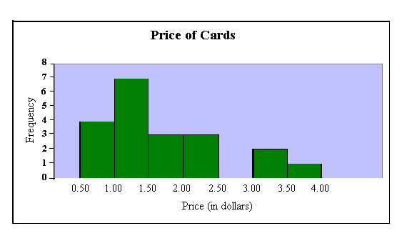**Histograms**

A **histogram** is a special type of bar graph. It shows a range of continuous data on the horizontal axis grouped into what are called classes. There is no space between the bars of a histogram because the data is continuous, and the width of each bar that represents the classes is the same.

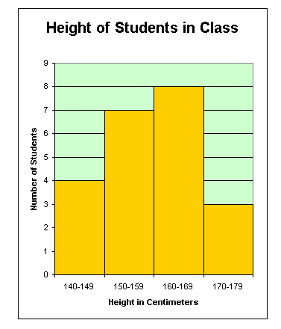

On the graph above, the label on the vertical axis is “Frequency”. This simply tells us how often the item on the horizontal axis occurred. The vertical axis could also have a more descriptive title. In this case, it might say “Number of Cards”.

On the graph to the left, the label on the vertical axis is more descriptive, saying “Number of Students” rather than frequency. This is the preferred way to label the axis.

Also notice that the range of values horizontal axis in each graph is shown differently. Both show a range, but the graph above shows labels at the ends of each bar on the histogram while the graph to the left shows the entire range written under the bar. The preferred way to show the range is the graph at the top of the page.

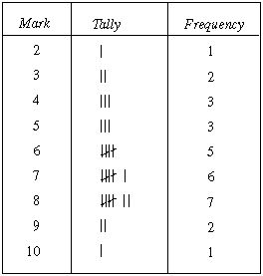 Marks on Math Quiz

The data used to plot a histogram comes from a tally chart or a frequency table. A tally chart lists the classes to be plotted and has tally marks for each time there is a piece of data in that class. A frequency table summarizes the tally marks into number data. Sometimes, both types of data are combined in the same table as seen here.

Example 1: Use the attached histogram to answer the following questions.

a) What are the intervals or classes shown on this histogram?

b) In which interval did the most people watch TV?

c) Which interval time had the least number of people watching TV?

Solution:

a) The classes or intervals are:

0 – 5 hours, 5 – 10 hours, 10 – 15 hours, 15 – 20 hours, 20 – 25 hours, 25 – 30 hours, and 30 – 35 hours

b) The most people watched 15 to 20 hours of TV

c) The least people watched 30 -35 hours of TV per week.

**ASSIGNMENT 5 – INTERPRETING Histograms**

Use the data in the following histograms to answer the questions.

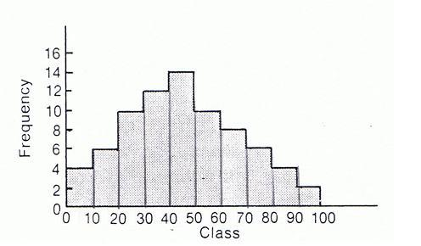

1. What are the classes in this histogram? List them.

______________________________________________

2. In which class (or interval) does the most data occur?

______________________________________________

3. In which class (or interval) does the least data occur?

______________________________________________

Masses of Players on

School Football Team

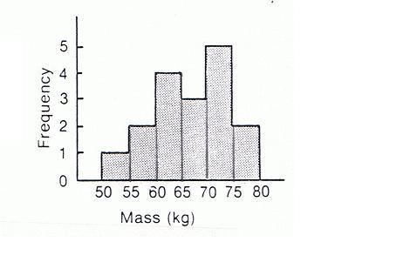4. How many students have a mass between 55 and 60 kg?

______________________________________________

5. How many students have a mass between 70 and 75 kg?

______________________________________________

6. How many students have a mass of less than 70 kg?

______________________________________________

7. How many students have a mass of 70 kg or more?

______________________________________________

8. How many students are on the football team?

______________________________________________

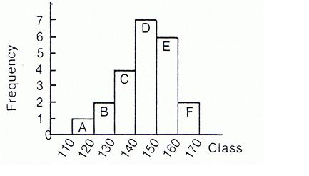9. How many classes are there in this histogram? ______________________________________________

10. What are the classes?

______________________________________________

11. In which class does the greatest frequency occur? ______________________________________________

12. Which 2 classes have the same frequency?

______________________________________________

**CREATING HISTOGRAMS**

Most of the histograms you will be drawing already have the first 3 steps completed and the frequency chart drawn. In case you are presented with raw data, you need to understand how the frequency chart is created.

1. Gather the data you are interested in.

The example data here represents the heights of students in Grade 11 in centimetres.

152 161 189 158 177 167 182 155 171 163 185 173 183

166 177 172 157 168 181 167 188 158 168 162 159 153

171 186 152 167 173 175 159 184 189 187 162 151 179

163 185 183 177 176 152 174 179 182 158 172 186 171

185 157 173 188 152 176 187 157 172 179

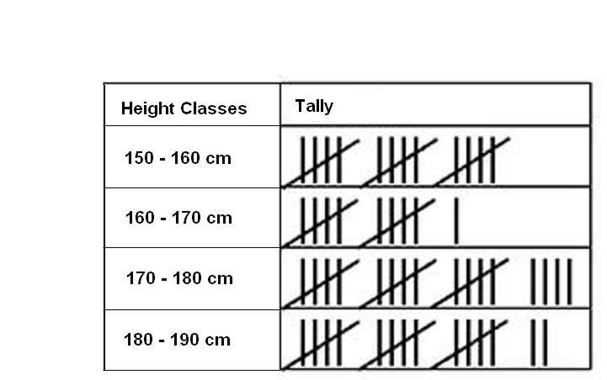

1. Look at the data and determine the categories or intervals you will use to organize the data. Sometimes the classes will be given to you. Other times you must determine them from the data. The tally chart here shows the results of a survey about height of students in Grade 11.

|  |  |
| --- | --- |
| **Height (cm)** | **Number of Students** |
| 150 – 160 | 15 |
| 160 – 170 | 11 |
| 170 – 180 | 19 |
| 180 – 190 | 17 |

1. Construct a frequency table for your data. The frequency corresponds to the number of times each value is observed. Using this example, the frequency table might look like this.

**THIS IS WHERE MOST OF THE DATA YOU WILL BE WORKING WITH WILL START – WITH A PREMADE FREQUENCY TABLE.**

1. To create the histogram, draw a horizontal and a vertical axis. The horizontal axis (X) shows the data categories (such as time, or a measurement, like weight). In this case, it would be **Height**. The vertical axis (Y) represents the frequency of the observations (the number of observations for each category). In this case it would be **Number of Students**.
2. For each category of data, draw a rectangle (without space between the rectangles). The width of the rectangle represents the interval between two groups, and the height represents the observed frequency.

The histogram for this data is found on the next page.

**ASSIGNMENT 6 – CREATING HISTOGRAMS**

1) The table below gives data on the distribution of the age of teachers at a large high school. Use this data to draw a histogram on the grid paper on the next page.

|  |  |  |  |  |  |  |
| --- | --- | --- | --- | --- | --- | --- |
| ***Age of Teachers at Central High School*** | | | | | | |
| *Age* | *Less than 25* | *25 – 34* | *35 – 44* | *45 – 54* | *55 – 64* | *65 and older* |
| Number | 3 | 18 | 30 | 22 | 17 | 2 |

2) The table below shows the Average Daily Temperatures in Yellowknife, NWT in July. Use this data to draw a histogram on the second grid paper on the next page.

|  |  |  |  |  |  |
| --- | --- | --- | --- | --- | --- |
| ***Average Daily July Temperatures, Yellowknife, NWT*** | | | | | |
| *Temperature (0C)* | *10 – 13* | *13 – 16* | *16 – 19* | *19 – 22* | *22 – 25* |
| Number of Days | 2 | 8 | 7 | 13 | 1 |



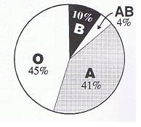**Circle Graphs**

A **circle graph** (or pie chart) is used when we want to show comparisons about parts that make up the whole amount. It could be something as simple as the distribution of blood types from data from the Canadian Red Cross blood donors as shown in this circle graph. Circle graphs can also show very complicated data, with many sectors.

Blood Types

Example: The following circle graph shows the distribution of books in Mary’s home library. Use the graph to answer the questions.

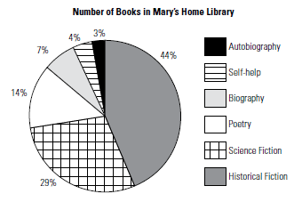

a) What percentage of Mary’s books are Science Fiction?

b) Which category of books does Mary have the fewest of?

c) If Mary has 72 books in her library, how many are Biographies?

Solution:

a) From the graph, 29% of Mary’s books are Science Fiction.

b) Mary has the fewest books in the Autobiography category.

c) Mary has said that 7% of her books are Biographies. To find how many books this represents, calculate as follow:

7 ÷ 100 × 72 = 5.04

Mary has 5 books that are Biographies.

**ASSIGNMENT 7 – INTERPRETING CIRCLE GRAPHS**

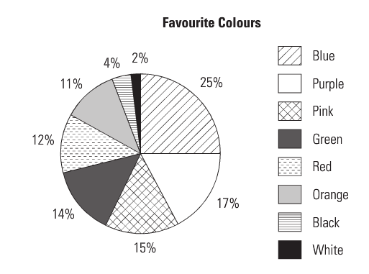1) The circle graph of Favourite Colours was created after several students surveyed their grade. There were 175 students surveyed.

a) What colour did most students respond was their favourite?

b) What was the least favourite colour?

c) How *many* students responded that red was their favourite colour?

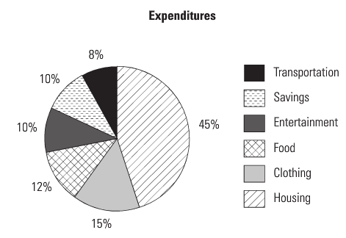2) Grace’s expenses are shown in this circle graph.

a) What two expenses did she spend the same amount on?

b) Which expense does she spend the most on?

c) What is her combined percentage spent on clothing and food?

d) If she saves $275.00 each month, how much does she earn?

**DRAWING ANGLES**

In order to draw a circle graph accurately, angles must be constructed using a protractor that correspond to the size that each “slice” of the pie represents.

To construct an angle, do the following:

* + 1. Draw a straight line about 5 – 10 cm long. On one end, mark a “tick” as shown below.
    2. Place the protractor on the line with the tick directly under the perpendicular line going up to 900 and the line you drew directly under one of the horizontal sides out to zero.
    3. Mark the location of the degrees of the angle you wish to draw. In this example, 530 is plotted. ***Be careful to follow the correct scale***. This means that if you start on the right side at zero, follow the **INSIDE** scale around until you reach the angle measure you require.
    4. Draw a line from the tick to the mark you made for the angle measure. This now forms the angle you were required to construct.

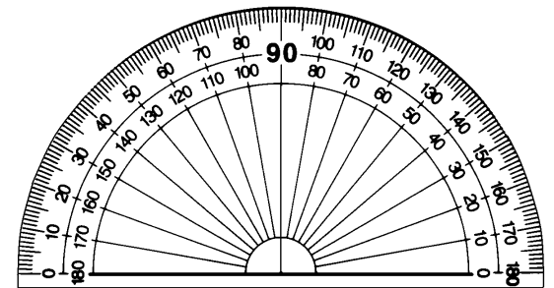

1. ii)



iii) 530 iv)

530

When constructing angles, always do it on plain or unlined paper.

**ASSIGNMENT 8 – DRAWING ANGLES**

Construct the following angles in the space below.

1) 650 2) 1580

3) 1250 4) 900

5) 110 6) 1310

7) 1120 8) 420

**CREATING CIRCLE GRAPHS**

To plot a circle graph, the amount or percentage given must first be converted to degrees and then the appropriate angles are plotted. Every circle has a degree measure of 3600 and half of that is shown on a standard protractor. You will always be given a circle base to plot your graphs in. Make sure you use it!

|  |  |
| --- | --- |
| **Expenditure** | **Percentage** |
| Travel | 5 % |
| Personal | 16% |
| Food | 14% |
| Housing | 10% |
| Books | 3% |
| Tuition | 52% |

Example 1: Construct a circle graph to show what amount of a college student’s budget is spent in each category.

Solution: In order to plot this data accurately, each percentage in the table to the right must be converted into a degree measurement. To do this, divide each percent by 100 to get as a non-percentage number, and multiply by 3600. Round each angle to the closet whole degree. This is an example of the calculations, but the calculation part does not need to be written on the circle graph blanks provided for this task.

|  |  |  |  |
| --- | --- | --- | --- |
| **Expenditure** | **Percentage** | **Calculation** | **Angle** |
| Travel | 5 % | 5 ÷ 100 ×360 = 180 | 180 |
| Personal | 16% | 16 ÷ 100 ×360 = 57.80 | 580 |
| Food | 14% | 14 ÷ 100 ×360 = 50.40 | 500 |
| Housing | 10% | 10 ÷ 100 ×360 = 360 | 360 |
| Books | 3% | 3 ÷ 100 ×360 = 10.80 | 110 |
| Tuition | 52% | 52 ÷ 100 ×360 = 187.20 | 1870 |

In the circle blank provided, construct the first angle. When it is plotted, use its second line as the start for the next angle. When there are angles greater than 1800, plot all the other angles and leave the big angle as the area leftover at the end.

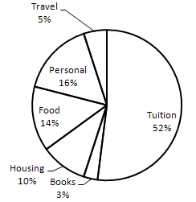For each graph, label the sections and write a title. A legend is not required, nor is it necessary to colour the sectors. If the sectors are too small, a line pointing at the sector with the label can be used.

College Expenses

Often, the amounts given for each sector for a circle graph will not be expressed as a percent, but simply as a number. This type of data is handled slightly differently.

Example 2: Construct a circle graph to show the amounts of the nutritional make-up of a Protein Bar.

|  |  |
| --- | --- |
| **Ingredient** | **Mass (g)** |
| Protein | 34.0 |
| Carbohydrates | 33.0 |
| Fat | 6.0 |
| Sodium and potassium | 0.5 |
| Other | 11.5 |
| Total | 85.0 |

Solution: Notice that these ingredients are listed as parts of the 85 gram total. To use this data, we must find the percent of the whole before finding the angle.

|  |  |  |  |  |
| --- | --- | --- | --- | --- |
| **Ingredient** | **Mass (g)** | **Percentage of Total Mass** | **Angle Calculation** | **Angle** |
| Protein | 34.0 | 34 ÷ 85 × 100 = 40 | 40 ÷ 100 ×360 = 1440 | 1440 |
| Carbohydrates | 33.0 | 33 ÷ 85 × 100 = 38.8 | 38.8 ÷ 100 ×360 = 139.70 | 1400 |
| Fat | 6.0 | 6 ÷ 85 × 100 = 7.1 | 7.1 ÷ 100 ×360 = 25.60 | 260 |
| Sodium and potassium | 0.5 | 0.5 ÷ 85 × 100 = 0.6 | 0.6 ÷ 100 ×360 = 2.20 | 20 |
| Other | 11.5 | 11.5 ÷ 85 × 100 = 13.5 | 13.5 ÷ 100 ×360 = 48.60 | 490 |
| Total | 85.0 | 100% | 3600 | 3600 |

The circle graph is plotted below.

Protein Bar Nutritional Ingredients

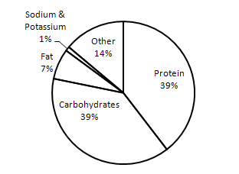

**ASSIGNMENT 9 – CREATING CIRCLE GRAPHS**

Construct a circle graph to show each set of data.

1) Type of Pet

|  |  |  |  |
| --- | --- | --- | --- |
| **Pet** | **Percentage** | **Calculation** | **Angle** |
| Cat | 30 |  |  |
| Dog | 34 |  |  |
| Mouse/Rat | 4 |  |  |
| Gerbil | 13 |  |  |
| No pet | 19 |  |  |
| Total |  |  |  |

2) Transportation to School

|  |  |  |  |  |
| --- | --- | --- | --- | --- |
| **Method of Travel** | **Number of People** | **Percentage of Total People** | **Angle Calculation** | **Angle** |
| Drive | 12 |  |  |  |
| Ride from parent | 63 |  |  |  |
| Carpool | 20 |  |  |  |
| Motorbike | 5 |  |  |  |
| Bus | 75 |  |  |  |
| Bicycle | 10 |  |  |  |
| Walk | 15 |  |  |  |
| Total |  | 100% | 3600 | 3600 |

3) Daily Activities

Sleep: 8 hrs School: 4 hrs Job: 5 hrs Homework: 1 hr

Meals: 2 hrs Relaxation: 2.5 hrs Travel: 1.5 hrs

|  |  |  |  |  |
| --- | --- | --- | --- | --- |
|  |  |  |  |  |
|  |  |  |  |  |
|  |  |  |  |  |
|  |  |  |  |  |
|  |  |  |  |  |
|  |  |  |  |  |
|  |  |  |  |  |
|  |  |  |  |  |
| Total |  | 100% | 3600 | 3600 |

**MISLEADING GRAPHS**

Any graph can be made to seem misleading. By increasing or decreasing the scale, changing the starting point on an axis – especially not starting at zero – you can make the viewer see the data in a certain way. Distorting or skewing the data in this way makes the graph, or any other kind of statistic, misleading.

We have already touched on one way graphs can be misleading. If the vertical axis of a graph does not start at zero, a whole lot of the data is “missing.” Look at the next graph.

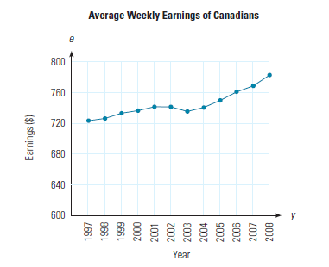

When looking at this broken line graph, it appears that there has been a big increase between 1997 and 2008 in the average weekly earnings of Canadians.

But look a little more closely. The Earnings on the vertical axis starts at $600 and only goes up to $800. The increments on the axis are $40. This makes the increase seem large when it really isn’t that big. This could be misleading to people who don’t carefully look at the scale on the vertical axis.

A graph that represents the data fairly and more accurately (not misleading) is illustrated here. See how the increase in earnings does not seem so large over the period of time? The vertical scale starts at zero rather than just showing a chunk of the graph.

In the next graph, while the graph appears to start at zero, the first 60+ students have been cut from the bottom of the graph. This makes the bars look much shorter than they really are and thus does not represent the data fairly or accurately. All three Schools shown on this graph actually have bars that are more than double the size (length) of what is shown. It appears that the graduation rate for School B is almost double that of School A based on the size of the bars. In fact, they are much closer, differing by less than 10 students for both boys and girls.

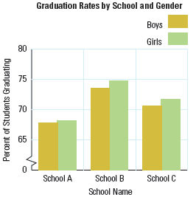

Graphs can also be misleading when the increment on the vertical axis is not consistent. Bar graphs as well as broken line graphs can be misleading. Histograms and circle graphs are less likely to be misleading unless they are drawn incorrectly.

**Things to watch for to tell if graphs are misleading:**

* + **Does the vertical axis start at zero?**
  + **Is there a gap between zero and the next value?**
  + **Are the increments along the vertical axis the same? That means does each grid line represent the same amount on the scale.**
  + **Are the bars on a bar graph all the same width?**
  + **Is the space between bars on a bar graph the same?**
  + **Is the scale on the horizontal axis on a broken line graph squished?**
  + **Is the scale on the vertical axis on a broken line graph squished?**

**ASSIGNMENT 10 – MISLEADING GRAPHS**

1) Think about the two graphs below. They show the same data plotted in different ways.

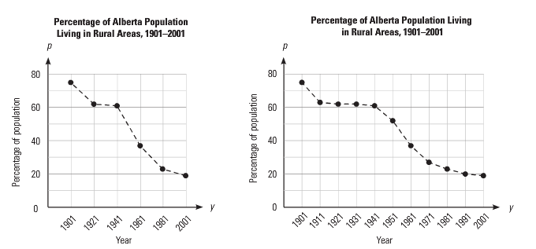

a) Which of the graphs makes it appear that the drop in the population living in rural areas was faster? Why is this?

b) Which graph do you think is a better representation of the actual change in the rural population? Why is this?

c) In what year was the population half rural and half urban?



2) Is this graph misleading? Why or why not.

3) Is this graph misleading? Why or why not.

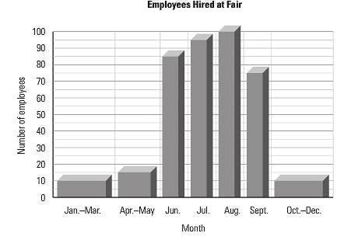

4) On the grid below, create a bar graph for question #3 that would represent the data more accurately and fairly.

**Ask your teacher for quiz 2**